Fernando Gonzales-Vigil

Project 5

**Test Plan**

|  |  |  |  |  |  |
| --- | --- | --- | --- | --- | --- |
| **Test Case #** | **Input** | **Actual input** | **Expected Output** | **Actual Output** | **Did Test Pass?** |
| 1 | Pick white ball and powerball myself – correct numbers | 14,17,23,  28,49, 19 | Data accepted  Result point is random | 0.00 points | YES |
| 2 | Wrong whiteball numbers to test validation | -5, 100, 70,0, 69, 1 | Returns to same question. Except 0 because 0 is default value, still rejects | Repeated question &  “You cannot repeat the same number, choose another.” | YES |
| 3 | Left whiteballs to random and powerball to selfpick | N, Y, 17 | Maybe this time I can match some points? | 1. points   No match  ☹ | YES |
| 4 | Let the PC generate randomly the white and powerball. | N, N | How many tries to win something? | 4.00 after the 6th time.  (Wonder why the Powerball accumulates that much!) | YES |

**Screen Output 1**

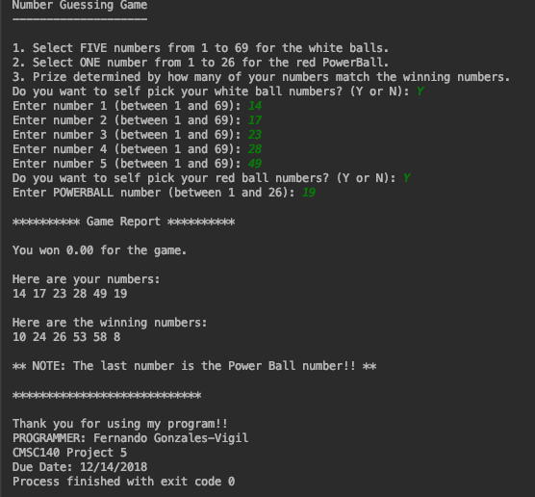

**Screen Output 2**

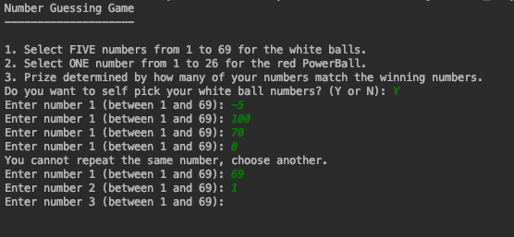

**Screen Output 3**

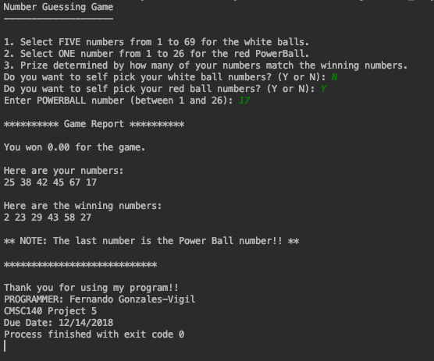

**Screen Output 4**

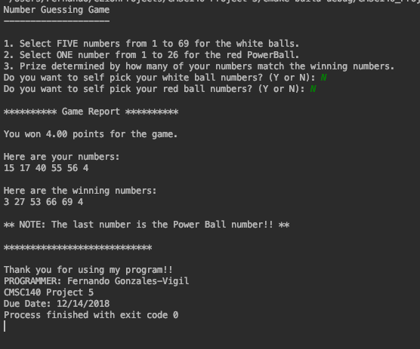

**Final File Output**

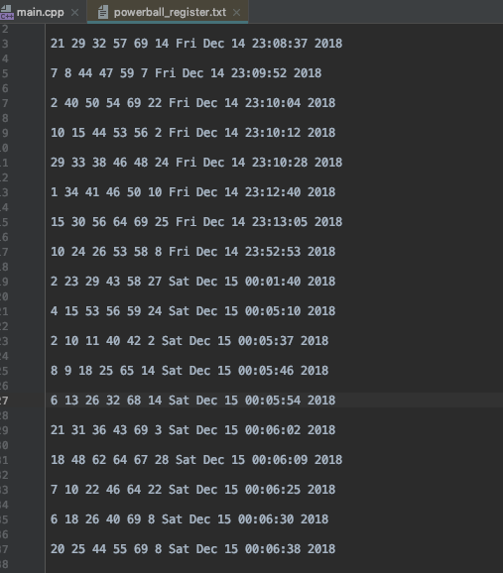

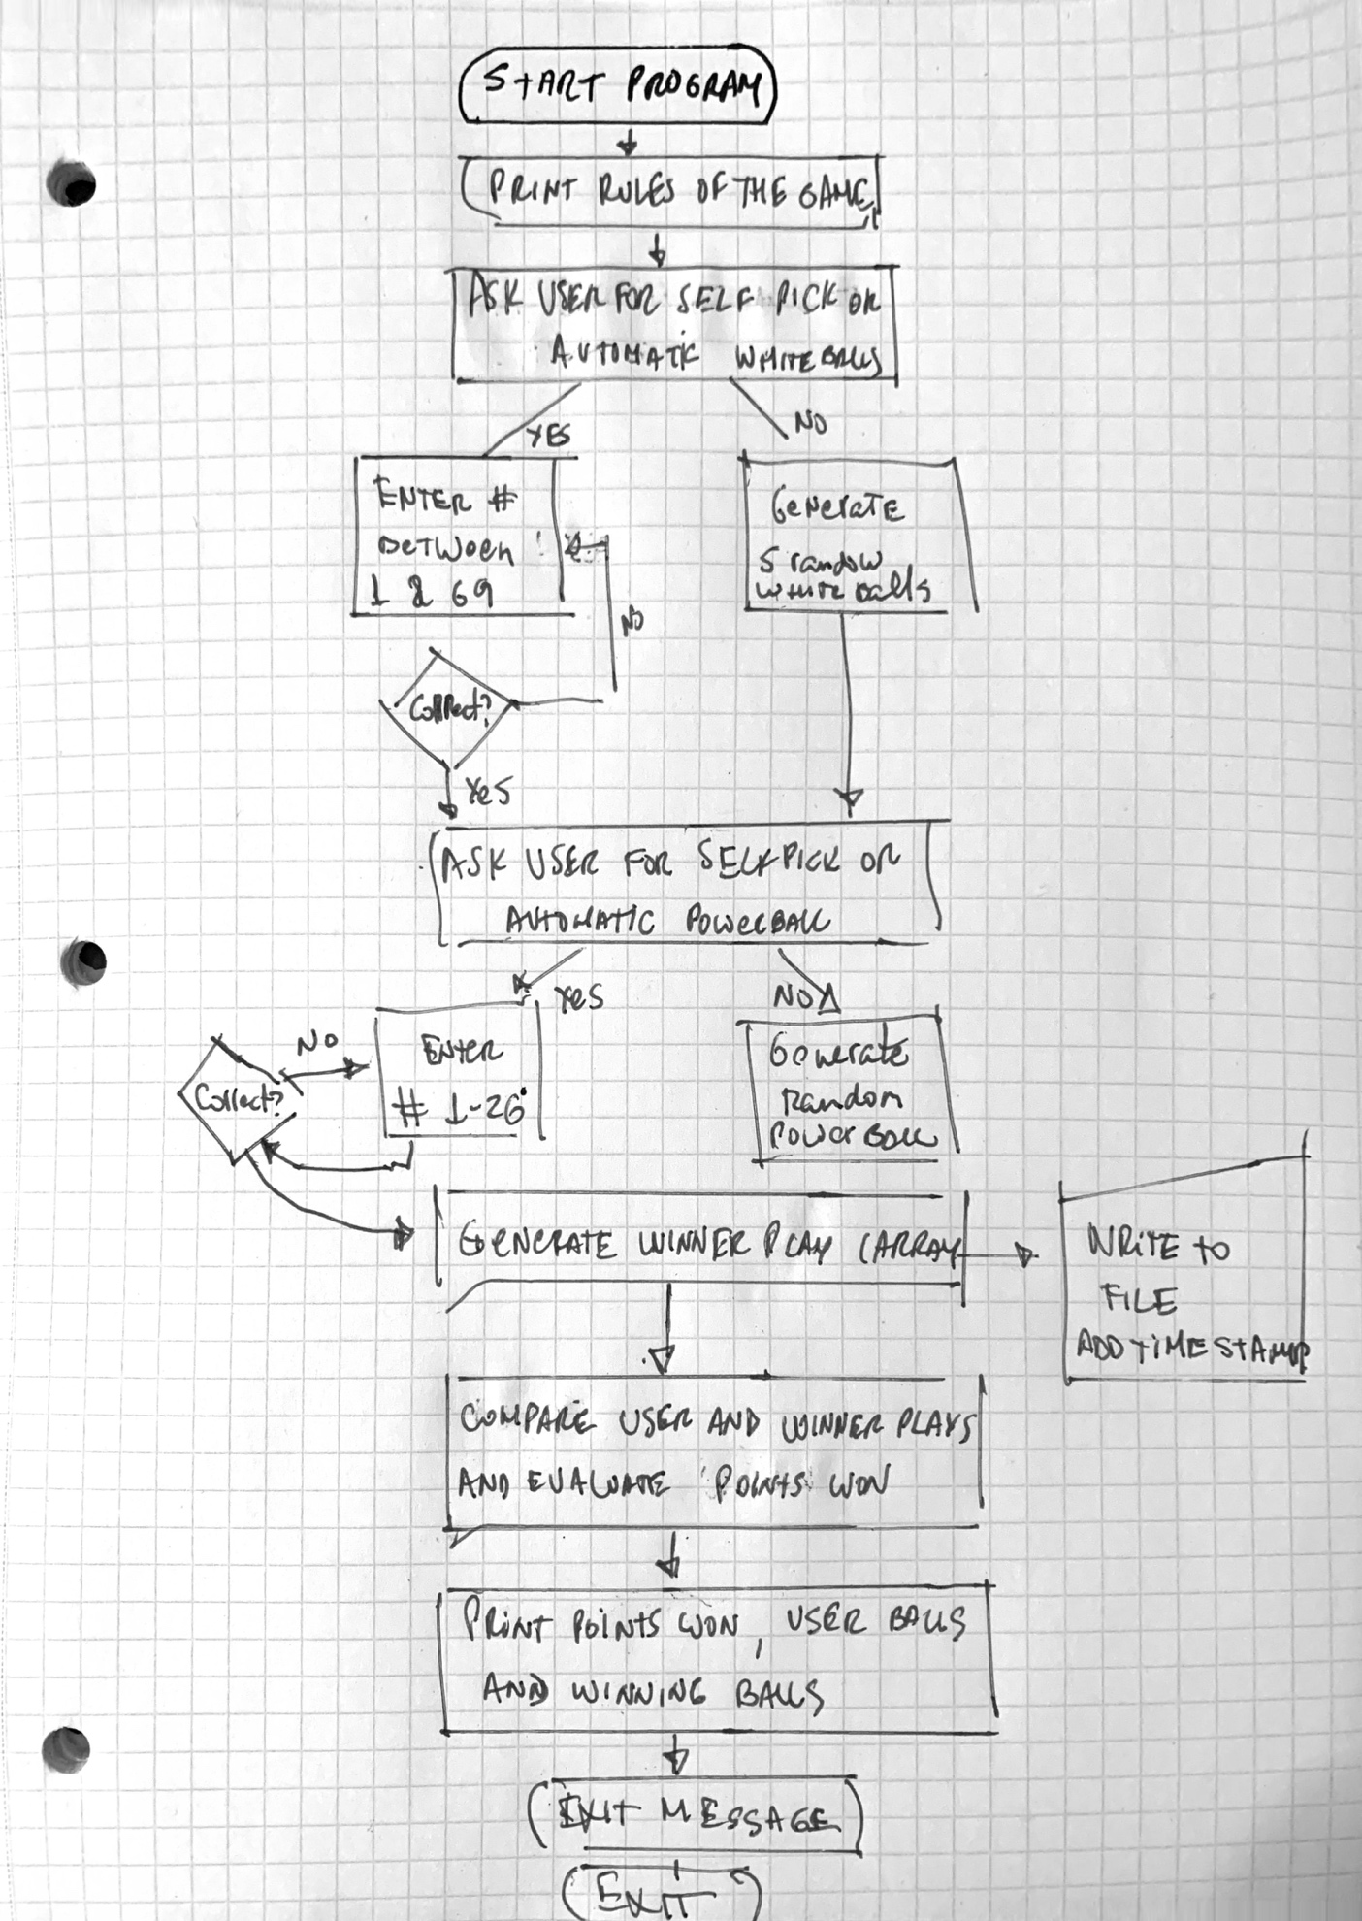

Lesson Learned:

In this project, I learned about not using rand() because for small numbers it may be indifferent, the larger the size of the range, the less random it becomes. Instead I used the C++11 alternative in the <random> library: random_device and uniform_int_distribution.

Also learned how to properly create a time stamp, using the <chrono> library that uses the system time and the convert it to a string.